#
# One very important thing!
# Under tmux this utilities don’t work.
# Need to open separate tab of MobaXterm with terminal and ssh session to remote server.
#

#
# Receive file from remote server to local computer.
#
[root@vm-vol-nag4-tst check_http]# yum install lrzsz

# In terminal window on MobaXterm.
# Run follow command.
[root@vm-vol-nag4-tst check_http]# sz http_request
▒lrz waiting to receive.*CD@@@@▒Q▒3http_request@734 12661035351 100755 0 1 734@k_▒K!

Receiving: http_request
*CJ@@@@▒▒▒▒#!/bin/bashJJSTATE_OK=0JSTATE_WARNING=1JSTATE_CRITICAL=2JSTATE_UNKNOWN=3JJthis=$(basename $0)JJfunction print_usage(){Jcat <<EOFJUsage: $this -q "<query>" -v "<value>"JEOFJ}JJWGET="/usr/bin/wget"Jif [ ! -x $WGET ]JthenJ echo "Can not find wget in $WGET"J exit $STATE_UNKNOWNJfiJJwhile getopts "q: v:" options; doJcase "$options" inJ q) query=$OPTARG >&2 ;;J v) value=$OPTARG >&2 ;;J \?) print_usageJ exit $STATE_UNKNOWN ;;JesacJdoneJJif [[ (-z "$query") && ( -z "$value") ]]; thenJ print_usageJ exit $STATE_UNKNOWNJfiJJRESULT=$($WGET -O - -q $query | grep -c $value)JJif [ "$RESULT" -gt 0 ]; thenJ echo "OK - Service is avaiable."J exit $STATE_OKJelseJ echo "CRITICAL - Service not avaiable."J exit $STATE_CRDownloading: 100% kBytes received: 0/ 0 kBPS:47
▒OO[root@vm-vol-nag4-tst check_http]#
Transfer complete

[root@vm-vol-nag4-tst check_http]#

# Then tap right button of mouse and choose “Receive file using Z-modem”.
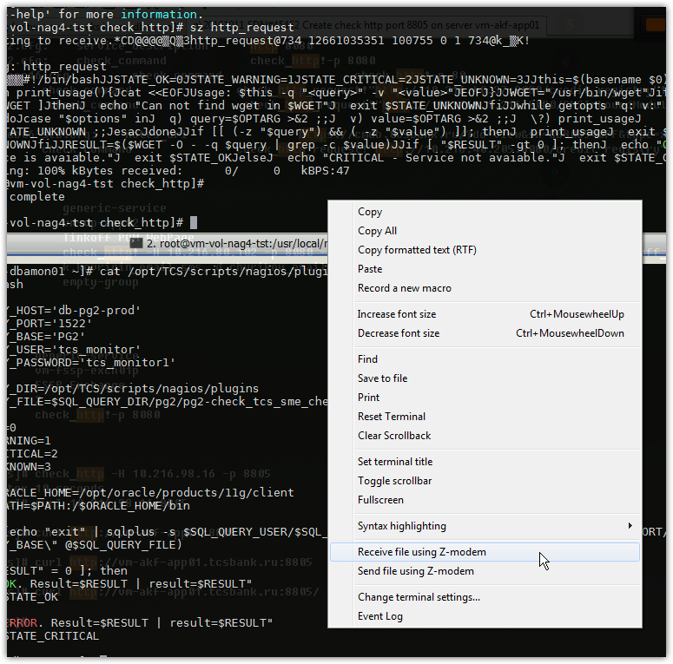

# Then choose folder on local computer, where save file.

# If something go wrong - terminal stuck, not print text.
# To cancel receiving file we need to delete windows task “lrz”. I found it in thread among “MobaXterm” tasks.
# Here. In this example it was already cancelled.
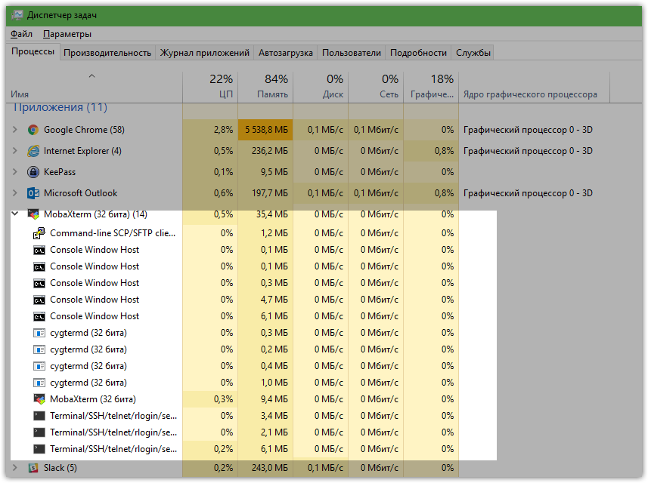

# Here is how looks sending file to remote server.
# On remote server run follow command “rz”.

[root@vm-webim-prod-mysql01 plugins]# rz
▒Sending: http_request**B0100000023be50
▒**B0900000000a87c

Bytes Sent: 734 BPS:5871
▒*B0800000000022d
Transfer complete
[root@vm-webim-prod-mysql01 plugins]#

# In context menu of moba xterm (right mouse button) choose “Send file using Z-modem”.

# In logs (right mouse button) of terminal we can see follow command.
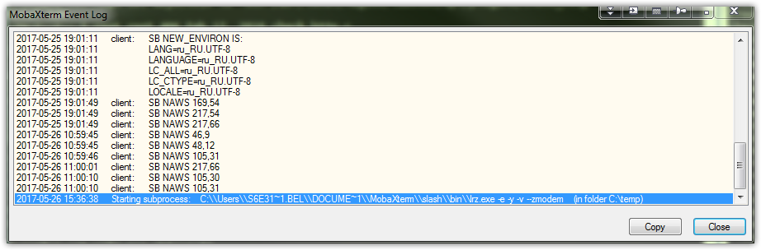
# If terminal hang up, we need open ms windows task monitor and stop process lrz.

